CASE STUDY: MERIT-CUM-MEANS SCHOLARSHIP ALLOCATION AND MULTI-CRITERIA RANKING SYSTEM
1 PROBLEM STATEMENT
Design and implement an automated scholarship allocation module that evaluates student applicants against multi-criteria constraints (academic aggregate, minimum subject score, attendance compliance, and family income), filters out ineligible candidates with specific failure reasons, and ranks eligible students using a complex multi-tier tie-breaking priority key to distribute limited scholarship slots.
2 OBJECTIVES
- Parse and evaluate multi-subject marks to calculate the academic aggregate percentage.
- Enforce rigorous eligibility checks (Minimum aggregate, subject floor score, attendance threshold, and maximum income ceiling).
- Implement a robust multi-key sorting mechanism prioritizing academic performance, financial need, and attendance.
- Allocate restricted scholarship slots and assign remaining eligible candidates to a waiting list.
3 KEY ASSUMPTIONS
Scholarship thresholds and total available slots are configurable inputs. The multi-tier sorting prioritizes higher academic performance, lower family income, higher attendance, and peak individual subject scores.
4 ALGORITHM
- Read configuration parameters (MIN_AGGREGATE, MIN_SUBJECT_MARK, MIN_ATTENDANCE, MAX_INCOME, TOTAL_SCHOLARSHIPS).
- Iterate through student profiles, compute their academic aggregate, and validate against all criteria.
- Separate students into eligible and rejected lists, recording the exact failure reason for rejections.
- Sort eligible students using a custom tuple key: descending aggregate, ascending income, descending attendance, descending max subject marks, and ascending student ID.
- Assign "SCHOLARSHIP AWARDED" up to the total limit, and place overflow candidates on the "Waiting list".
5 FLOWCHART REPRESENTATION
Plaintext
[Start] -> [Read Limits & Student Profiles] -> [Calculate Aggregate & Check Eligibility]
-> [Eligible? Yes: Add to Eligible | No: Add to Rejected with Reason]
-> [Sort Eligible via Custom Ranking Key] -> [Allocate Scholarships vs Waiting List]
-> [Display Final Audit Reports] -> [End]
6 PSEUDOCODE
Plaintext
FUNCTION allocate_scholarships():
FOR student IN students:
aggregate = SUM(marks) / LEN(marks)
IF aggregate < MIN_AGGREGATE OR min(marks) < MIN_SUB OR attendance < MIN_ATT OR income > MAX_INCOME:
REJECT with specific reason
ELSE:
ADD to eligible list
SORT eligible BY (-aggregate, income, -attendance, -max_mark, id)
ASSIGN "SCHOLARSHIP AWARDED" FOR rank <= TOTAL_SCHOLARSHIPS ELSE "Waiting list"
8 TEST CASES
Scenario / Input Limits | Sample Criteria Check | Expected Output Status
Min Aggr: 80, Min Sub: 40, Att: 75, Inc: 500k, Slots: 3 | Ravi (Score 35 in one subject) | Rejected (A subject score is below 40)
Min Aggr: 80, Min Sub: 40, Att: 75, Inc: 500k, Slots: 3 | Arjun (Income 800k > 500k) | Rejected (Income 800000 is above 500000)
Min Aggr: 80, Min Sub: 40, Att: 75, Inc: 500k, Slots: 3 | Top eligible students (e.g., Asha, Divya) | SCHOLARSHIP AWARDED / Waiting list
9 OUTPUT SCREENSHOTS
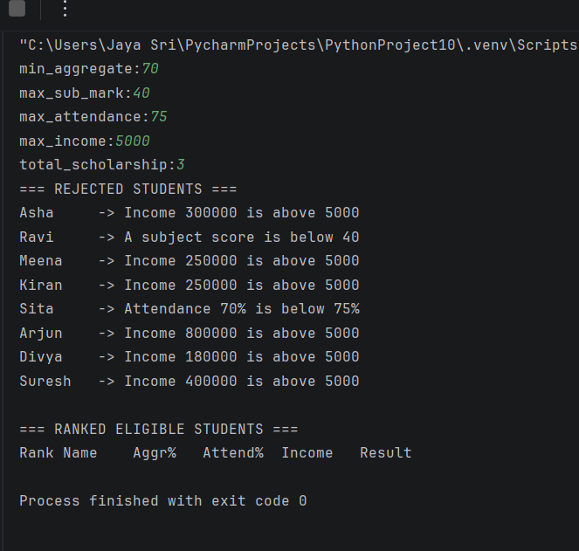s
10 CONCLUSION
The automated scholarship allocation module successfully parses complex multi-variable conditions, filters out disqualified candidates cleanly, and implements multi-tier priority sorting for fair resource distribution.

